<html>

<body>

<table border = "7">

<tr>

<th>SUNDAY</th>

<td colspan = "3">Mathematics</td>

<td>English</td>

<td>Chemistry theory</td>

<td> EGD practices</td>

</tr>

<tr>

<th>MONDAY</th>

<td colspan = "4">WDL</td>

<td colspan = "3">EGD Practices</td>

</tr>

<tr>

<th>TUESDAY</th>

<td colspan = "3">Mathematics</td>

<td colspan ="2">Engineering graphics</td>

<td colspan = "2">Chemistry Numericals</td>

</tr>

<tr>

<th>WEDNESDAY</th>

<td colspan = "3">EGD Practices</td>

<td colspan = "3">Chemistry Numericals</td>

</tr>

<tr>

<th>THURSDAY</th>

<td colspan = "2">CWL Revision</td>

<td colspan = "2">WDLRevision</td>

<td colspan = "2">completing backlogs</td>

</tr>

<tr>

<th>FRIDAY</th>

<td colspan = "4">EGD Practices</td>

<td colspan = "3">Chemistry THEORY</td>

</tr>

<tr>

<th>SATURDAY</th>

<td colspan = "2">all writing work done</td>

<td colspan = "3">reading other than syllabus(biography or some new book)</td>

</tr>

</table>

</body>

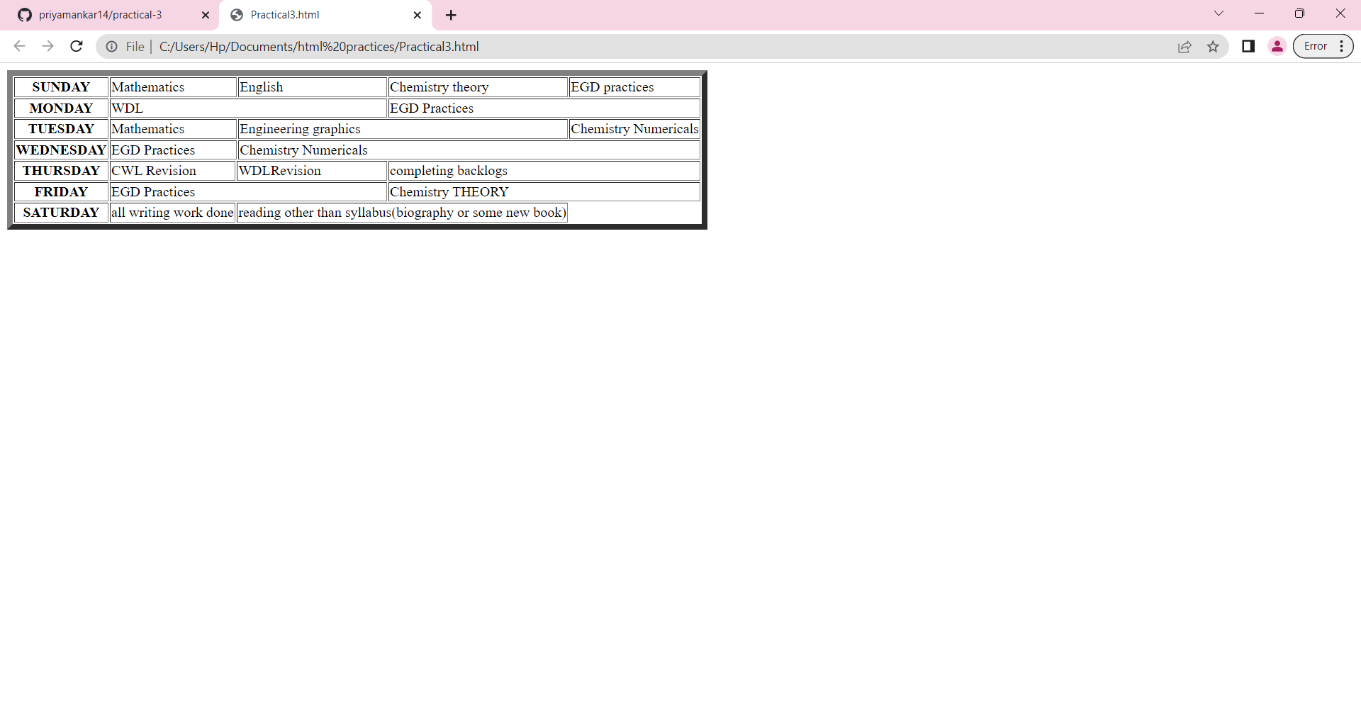</html>